**Frequency Synthesis:**

Just like an AC signal will superimpose on a DC signal, two AC signals present at the same time will also combine to form a new waveform. When this occurs it is refered to as **Frequency Synthesis.**

* **synthesis** [noun](https://www.merriam-webster.com/dictionary/noun) : the composition or combination of parts or elements so as to form a whole – Merriam Webster
* **Frequency Synthesis** is the process of combining multiple sine waves to produce a new desired waveform
* **Perfect Square Waves** are comprised of an infinite number of odd harmonic sine waves
* **Sawtooth, Exponential, and Triangle Waveforms** are comprised of a combination of odd and even harmonic sine waves.
* **Harmonics**
  + A harmonic is a multiple of the fundamental
  + Harmonics are numbered according to their ratio to the fundamental
  + 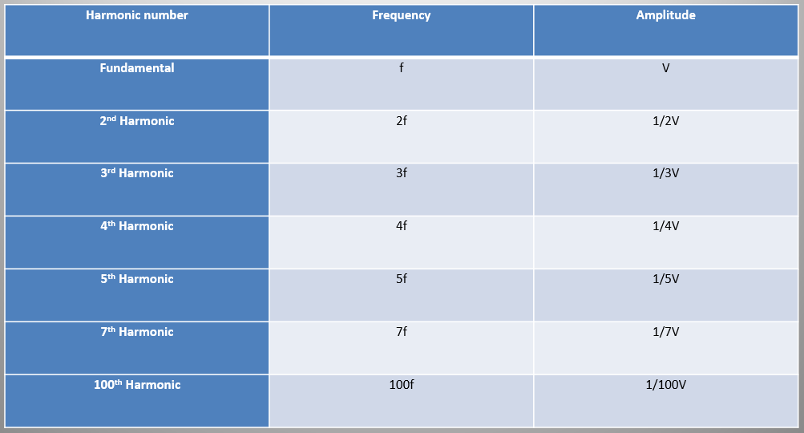The number of harmonics is infinite; however, the amplitude of each harmonic will successively decrease as frequency increases.
* 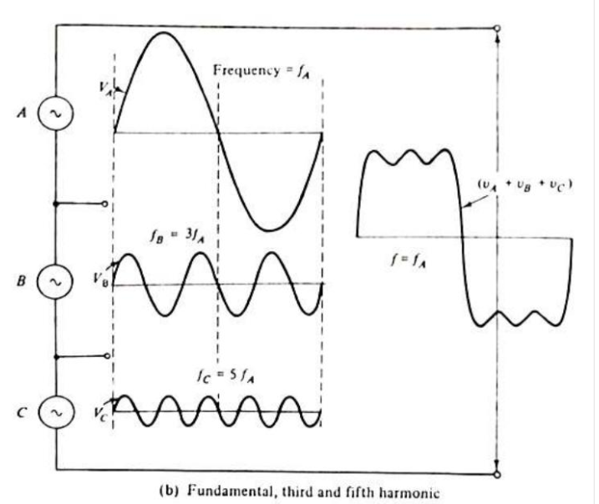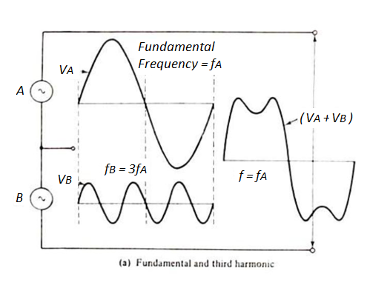**Frequency Synthesis Waveform Example**
* **Harmonic Analysis** is the converse of frequency synthesis
  + **Fourier Analysis** is the mathematical function by which waveforms can be analyzed to determine their harmonic content.
  + Suppose that a square wave with a frequency of 1Khz (Fundamental) is applied to an amplifier with an upper frequency limit of 15Khz. This amplifier will not reproduce sine waveforms with frequencies greater than 15Khz. Thus, the amplifier will not pass harmonics of 1Khz (the fundamental) beyond the 15th harmonic. If the Square wave applied was changed to 5Khz (fundamental), only the first, second, and third harmonic would be passed.
$Bandwidth=\#of Harmonics ×Fundamental$

$\#of Harmonics =\frac{Bandwidth}{Fundamental}$

$Fundamental =\frac{Bandwidth}{\#of Harmonics}$

* **Fourier Series Examples:** <https://www.falstad.com/fourier/e-index.html>

**References**:

* Bell, D. A. (1997). *Solid state pulse circuits*. Sarnia, ON: David A. Bell.
* Synthesis Merriam Webster. (n.d.). Retrieved from https://www.merriam-webster.com/dictionary/synthesis.